**6 Types of Construction Projects: Key Differences for Owners & Contractors**

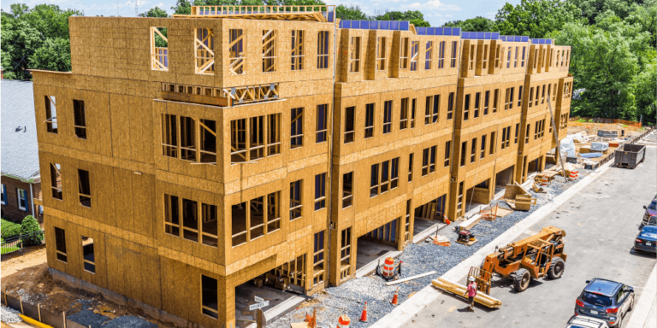

Construction projects are often categorized based on their scale, the types of structures being built, and the purpose of the project (also called “end use” or “land use”). Broadly, there are six types of construction projects: residential, commercial, institutional, mixed-use, industrial, and heavy civil.

Urban planners often categorize projects based on their “end use” to ensure development projects meet the varying needs of the communities in which they are built. Describing construction project types by their use can also help project owners and contractors understand the legal requirements – like compliance with zoning ordinances and building codes – and **anticipate the engineering needs and environmental impacts** of the project.

Because of the vast differences in scope, scale, cost, engineering requirements, equipment and building material needs, **developers and contractors frequently specialize in a particular type of construction project** (or several closely related types). Some contractors may also structure their organizational chart to include different business units, with each focused on a different type of construction.

Related: [9 types of construction companies](https://www.procore.com/library/types-of-construction-companies)

Table of contents

* [**1. Residential Projects**](https://www.procore.com/library/construction-project-types#1-residential-projects)
* [**2. Commercial Projects**](https://www.procore.com/library/construction-project-types#2-commercial-projects)
* [**3. Mixed-Use Projects**](https://www.procore.com/library/construction-project-types#3-mixed-use-projects)
* [**Vertical Mixed-Use**](https://www.procore.com/library/construction-project-types#vertical-mixed-use)
* [**Horizontal Mixed-Use**](https://www.procore.com/library/construction-project-types#horizontal-mixed-use)
* [**Transit-Oriented Developments**](https://www.procore.com/library/construction-project-types#transit-oriented-developments)
* [**Live-Work-Play Communities**](https://www.procore.com/library/construction-project-types#live-work-play-communities)
* [**4. Institutional Projects**](https://www.procore.com/library/construction-project-types#4-institutional-projects)
* [**5. Industrial Projects**](https://www.procore.com/library/construction-project-types#5-industrial-projects)
* [**6.** Civil & Infrastructure Projects](https://www.procore.com/library/construction-project-types#6-civil-infrastructure-projects)
* [**Regulatory & Safety Factors**](https://www.procore.com/library/construction-project-types#regulatory-safety-factors)
* [**Building Occupancy**](https://www.procore.com/library/construction-project-types#building-occupancy)
* [**Fire Resistance**](https://www.procore.com/library/construction-project-types#fire-resistance)
* [**Improving Outcomes for Any Project Type**](https://www.procore.com/library/construction-project-types#improving-outcomes-for-any-project-type)

**1. Residential Projects**

Residential construction describes structures built for habitation. This category can be broken down further into single-family and multi-family construction. But even then, “multi-family” is often too broad a category to adequately describe a project’s needs and considerations.

Consider the construction of a duplex versus a condominium complex. While both are technically multi-family units, there is a significant difference in scale, cost, building materials, and engineering needs. From the perspective of both owners and contractors, construction of a high-density residential project (like a high-rise apartment building) generally **has more in common with a commercial project** than other types of residential projects.

**2. Commercial Projects**

[Commercial construction](https://www.procore.com/library/commercial-construction) is a broad category that can describe a wide variety of business facilities. These include offices, retail stores, shopping centers, [hotels](https://www.procore.com/library/hotel-construction), and other facilities built for commercial use.

Compared to residential construction, commercial projects are exponentially more complex. Commercial developers and designers must consider a vast array of needs – including function, safety, environment, energy efficiency, and accessibility, to name a few.

Watch a 2-minute video explaining some common differences between project types.

Typically, the price tags on these projects often require contractors and subcontractors to meet stricter standards for prequalification than residential contractors, like the [bonding capacity](https://www.procore.com/library/bonding-capacity) to support the contract amounts.

[What contractors need to know about construction bonds](https://www.procore.com/library/construction-bonds-guide)

The gap between residential and commercial construction is widened by **the sharp increase in financial risk, especially in the** [**predevelopment phase**](https://www.procore.com/library/construction-predevelopment-phase). Project owners will almost certainly need approval from a governing body or council in order to proceed – without approval, they are unlikely to qualify for the financing they need to fund the project.

Commercial construction projects must comply with specific building codes and standards that address public safety (like fire resistant materials, fire protection systems, emergency exits) and energy efficiency. Commercial buildings are also generally required to include accessibility features that comply with the [Americans with Disabilities Act](https://www.ada.gov/) (ADA).

**Stay updated on what’s happening in construction.**

Subscribe to Blueprint, Procore’s free construction newsletter, to get content from industry experts delivered straight to your inbox.



**3. Mixed-Use Projects**

Mixed-use construction projects **combine multiple types of construction and land use within a single development or area**. Mixed-use developments are designed to create more efficient and integrated communities by providing a variety of functions in close proximity to each other. They often include a mix of residential and commercial units, recreational facilities, green space, and public amenities to create vibrant, convenient urban or suburban environments.

Mixed-use developments are popular among developers as [a tool to reduce financial risk](https://www.procore.com/library/construction-risk-management), **allowing them to diversify their portfolio within the same building**. If demand for office space weakens (say, during a pandemic), the residential and retail units may help the owner mitigate their losses. However, accommodating multiple end uses within a single development invites an increase in project complexity at almost all phases of the project – and a corresponding rise in operational risk.

While there is a virtually endless variety of configurations, there are four common types of mixed-use construction projects: vertical mixed-use, horizontal mixed-use, transit-oriented developments, and live-work-play communities.

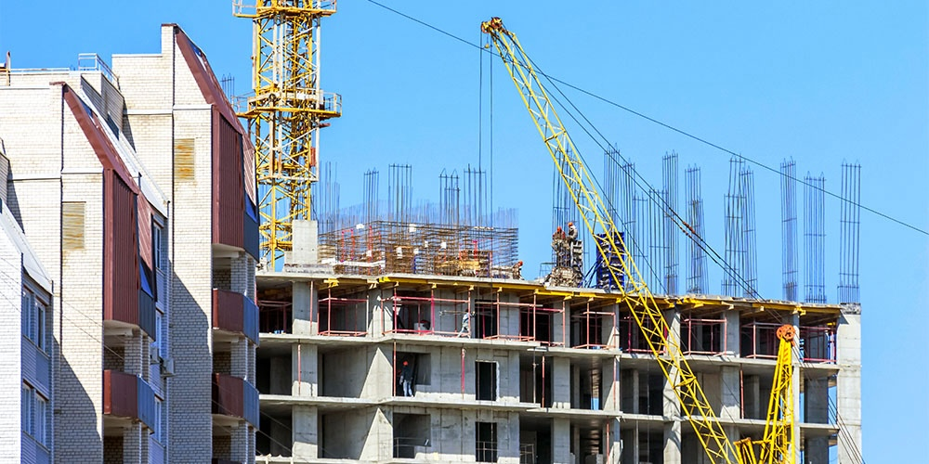

**Vertical Mixed-Use**

A vertical mixed-use project stacks different end uses within a single building – for example, retail spaces on the ground floor, office spaces on middle floors, and residential units on upper floors. They are common in densely populated areas, especially as [urban infill](https://en.wikipedia.org/wiki/Infill), where property is scarce.

**Horizontal Mixed-Use**

Where vertical mixed-use projects build *up*, horizontal mixed-use developments build *out*. As a result, this type of project is more common in suburban settings where space is cheaper and more readily available. Individual buildings within the development typically have their own designated uses.

[**Learn more about the differences between horizontal and vertical construction**](https://www.procore.com/library/horizontal-vs-vertical-construction)

**Transit-Oriented Developments**

[Transit-oriented developments](https://www.transit.dot.gov/TOD) (TODs) include a variety of facilities (residential units, office space, retail stores, public amenities) designed within walking distance of public transit hubs (e.g. train stations or bus terminals), to reduce reliance on private vehicles. These projects often combine vertical and horizontal mixed-use developments.

TODs may coincide with the launch of a new transit station, or may be built to revitalize adoption of an existing but underused hub. Developers can often qualify for federal or state funds earmarked to encourage investment in transit-oriented developments, which foster increased ridership and improvements in community connectivity and accessibility.

**Live-Work-Play Communities**

Live-work-play communities are designed to include a variety of options for living, working, and pursuing leisure or recreational activities within the same neighborhood. Often built as horizontal developments spanning multiple blocks or even acres, live-work-play communities are increasingly common in suburban locations.

**Free e-book**

**The Keys to Success in Commercial Construction**

Learn the financial strategies and business practices that lead to positive cash flow and long-term growth.

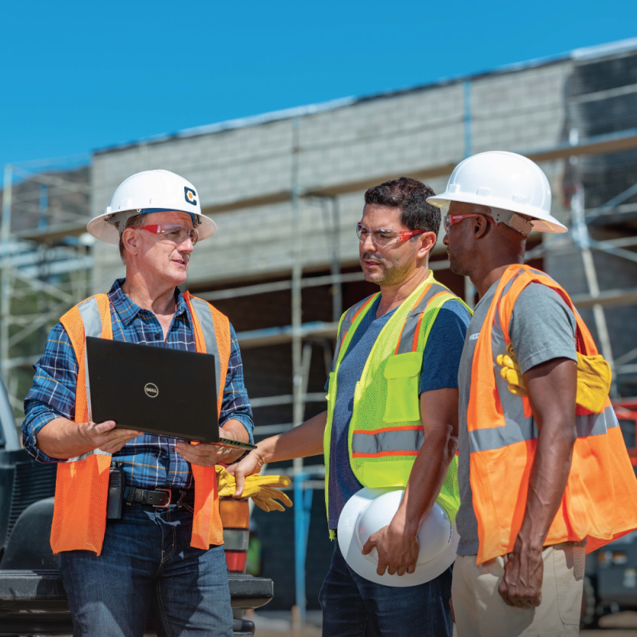

**4. Institutional Projects**

Institutional construction generally describes projects intended for public use, such as educational institutions, [hospitals](https://www.procore.com/library/hospital-construction), government buildings, and other public service facilities. In a way, this type of project is a “public” version of a commercial project.

While many institutional projects are public projects (i.e. owned by a public agency), they may also be privately developed, owned, and/or operated. As a result, there is significant overlap between commercial and institutional construction when it comes to design requirements, building materials, and equipment needs.

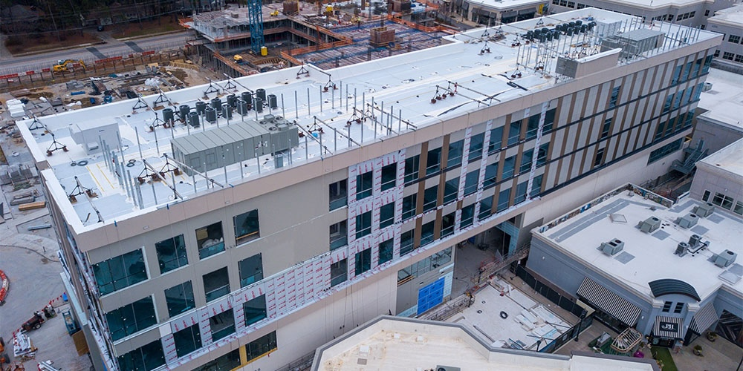

**5. Industrial Projects**

Industrial construction describes projects built for industrial use, such as manufacturing plants, warehouses, and power plants. Examples include factories, chemical processing facilities, and oil refineries.

Industrial projects are often subject to heavier governmental regulation, especially with respect to environmental impact. These types of projects typically require a high degree of specialized engineering, with material specifications not often found in other construction projects.

**6. Civil & Infrastructure Projects**

[Heavy civil construction](https://www.procore.com/library/heavy-civil-construction) describes large-scale engineering projects typically associated with infrastructure or public works. Civil projects include transportation systems (e.g. highways, bridges and tunnels, railways, [airports](https://www.procore.com/library/airport-construction)), utilities (e.g. water and sewage systems, communication and power distribution networks) and other large-scale public works projects. These projects are often referred to broadly as "horizontal construction" because they are typically longer than they are tall.

Civil and infrastructure projects are typically highly engineered with complex designs. As a result, the [predevelopment phase](https://www.procore.com/library/construction-predevelopment-phase) and preconstruction phase can be incredibly extensive. It is not uncommon for preconstruction on a civil project to span multiple years.

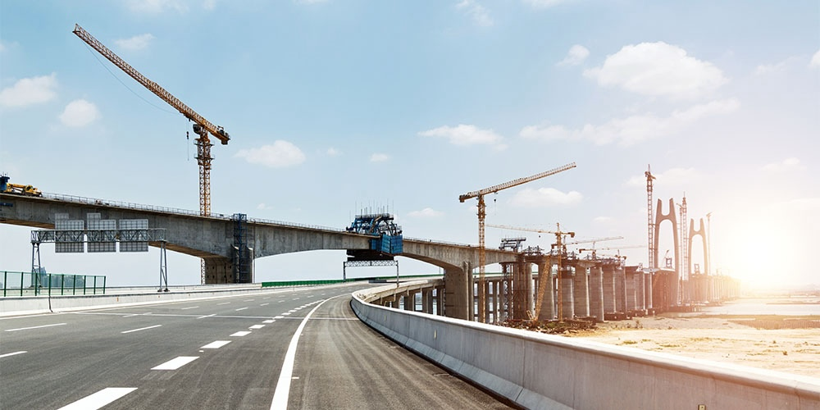

The pool of contractors available to agencies undertaking civil or infrastructure projects tend to be significantly more limited than on other types of projects. This is in large part due to the high barriers to entry: Heavy civil projects often require specialized heavy equipment and demonstrated experience delivering unique project specifications.

Contractors often start out subcontracting on smaller civil projects in order to build their resume – and relationships – before bidding on bigger government contracts. Others may partner with an existing government contractor to develop the civil construction experience necessary to qualify for [open bidding](https://proest.com/construction/process/types-of-tenders/).